LPSD 4.0 release document

MULTIPLICATIVE FINAL REPORT

Sign-off and approval

Table of Contents

INTRODUCTION 3

General 3

Current State 3

Unlocked CVM State 4

Reductive 5

TEST CASES 6

CVM TEST CASE 1 METRIC – V87 6

CVM TEST CASE 2 – V50 10

CVM TEST CASE 3 REV B – V26 13

CVM TEST CASE 4 – V41 17

CVM TEST CASE 5 – V53 22

CVM TEST CASE 6F – V33 24

CVM TEST CASE 6E – VXX 29

CVM TEST CASE 7 – V55 30

# INTRODUCTION

## General

The LPSD 4.0 project set out to create the next generation software for completing lightning protection system designs. A lightning protection system design software must have the ability to 1) place specific lightning protection materials on one or more buildings and 2) validate that the placed materials protect the building(s) to the specified lightning protection level (if applicable). Among these validation methods included in LPSD 4.0 is the Collection Volume Method (CVM). This method is based on the research or A.J. Eriksson and expanded upon by Franco D’Alessandro. The results of their research was implemented in previous generations of this software for the use by nVent ERICO. LPSD 4.0 attempts to adapt this process in a new cloud-based software, but uses the same basic methodology, equations, and logic present in earlier software.

## Current State

As of the drafting of this CVM checklist (November 16, 2022), the initial version of LPSD 4.0 has been launched and is in use by an internal design team for the nVent ERICO System 2000 and System 1000. The methods of validation for these other methods are more simplistic and purely geometric and algebraic in nature and therefore significantly easier to implement. By contrast, the CVM requires more data from the building model and processes it through several complex steps to generate a collection volume for any point of interest (POI) on each building(s). The functional needs of the CVM and their current status are shown below.

Placement Tools:

* System 3000 Components
  + Air terminal assemblies including Dynasphere and Mast Assemblies
  + Can be placed on horizontal (Guyed) or vertical (Cantilevered) surfaces
  + Can place cable, tiedowns, and connectors
  + Can place ground plane and ground electrodes
* Analysis Levels
  + Can add level planes at specified heights for each building model
  + Can add Sub-levels within the same level on a single building
* Analysis spheres
  + Can use analyze form tool to place a grid of horizontal and vertical analysis spheres at a fixed spacing per building model
  + Can manually place analysis spheres individually or with a spaced line tool
  + Can assign analysis spheres to a level or sub-level
  + Can group sets of analysis spheres as “virtual” buildings within one or more building models
  + Can modify the type of Analysis sphere: Corner, Rectangular Edge, Rectangular Middle, Cylindrical Edge, Cylindrical Middle, Gable Edge

Field Intensification Factors:

* Determines the location of an air terminal on a Base or Extended Feature
* Calculates Field Intensification factors (Ki) for single-level rectangular and cylindrical buildings
* Calculates Field Intensification factors (Ki) for air terminals placed on single-level rectangular and cylindrical buildings.

Collection Volumes:

* Generates a striking distance curve for a given Ki and LPL
* Generates a Velocity-derived boundary curve for a given Ki and LPL
* Calculates an associated “attractive radius” and “attractive radius” height for each POI
* Displays Collection Volumes for air terminal POI and building feature POI
* Presents CVM Results in a dialogue box when selecting any collection volume that shows:
  + POI position (x,y,z), Height of Attractive radius, Attractive radius, De-rating Angle, Ki Total contribution, Ki total multiplicative, Ki total reductive, and Striking Distance

Validating Full Coverage:

* Evaluates if building POI Collection volumes are under a zone of protection generated from air terminal collection volumes
* Generates conic boundary based on a de-rating angle for air terminal POI
* Updates color of building POI collection volume when considered “Protected” (Green) and “Not Protected” (Red).

## Unlocked CVM State

Since the main priority for this project is to unlock our ability to use CVM within LPSD 4.0, this section will outline all the major functions that must be working for that to happen. The designer must be able to place all the required materials for a complete System 3000 design and validate whether or not the system provides full coverage of the building(s) being evaluated. This has and will continue to require the development of specific tools to be used by the CVM. Once these tools have been completed, they will be tested against a set of test cases and measured against manual or tool-assisted calculations. The Unlocked CVM state (the state in which CVM is implemented and tested to a point approved for use in LPSD 4.0 designs) of the previously mentioned functional needs of the CVM are shown below.

Placement Tools:

* System 3000 Component placement tools ✓
* Level/Sub Level Tool ✓
* Multiple Building Tool ✓
* Analyze Form/Analysis sphere placement ✓
  + Can modify the type of analysis sphere: Corner, Rectangular Edge, Rectangular Middle, Cylindrical Edge, Cylindrical Middle, ***Gable Edge U, Gable Edge L, Gable Corner U, Gable Corner L.*** ✓

Field Intensification Factors:

* Minimum Width Calculation Tool ✓
  + Identifies all points needed to calculate minimum width for each level/sub-level✓
  + Finds minimum width of each level/sub-level even when corner and edge analysis spheres are rotated relative to the native coordinate axes. Accurate to within ≤5° ✓
  + Determines the Level/Sub-Level Shape based on POI Types used for Minimum Width Calculations ✓
* Each POI should be able to know the following about itself: ✓
  + Position (x,y,z), Building Number, Level, Level shape, Level height, Level Minimum width, Sub-Level, Sub-level shape, Sub-level height, Sub-level Minimum width, “Extended” status, POI Type ✓
* Can calculate the multiplicative effects of POI or AT stacked on one another ✓
  + AT on Rectangular, Cylindrical, or Gable Single Level Structure ✓
  + Rectangular, Cylindrical, or Gable Extended Feature on Rectangular or Cylindrical Base ✓
  + AT on Rectangular, Cylindrical, or Gable Extended Features on Rectangular or Cylindrical Base ✓
* Can calculate the reductive effects imposed on a building POI ✓
  + Identifies all points on the same building and separate buildings that may reduce its field intensification factor ✓
  + Calculates total reductive factor based on each POI’s “Magic Point” ✓

Collection Volumes: ✓

* Generates a striking distance curve for a given Ki and LPL ✓
* Generates a Velocity-derived boundary curve for a given Ki and LPL ✓
* Calculates an associated “attractive radius” and “attractive radius” height for each POI ✓
* Displays Collection Volumes for air terminal POI and building feature POI ✓
* Presents CVM Results in a dialogue box when selecting any collection volume that shows: ✓
  + POI position (x,y,z), Height of Attractive radius (zr), Attractive radius (RA), De-rating Angle, Ki Total contribution (Ki), Ki total multiplicative, Ki total reductive, Striking Distance (ds) and “Extended” status ✓

Validating Full Coverage: ✓

* Can evaluate if analysis spheres are under a zone of protection generated from collection volume ✓
  + Updates color of analysis sphere and its collection volume, Green for “Protected” and Red for “Not Protected” ✓
  + Only considers analysis spheres that have a Collection Volume as they will be the most extreme points to check on each building ✓
* Can incorporate a de-rating angle when selected ✓
  + Used only when Level of the air terminal is taller than 60m (197ft) ✓
* Displays protection area in associated analysis reports or Revit exports ✓
  + Protection radius and (x,y) position should be transferred to Revit drawing so a protection circle can be drawn on the plan view ✓
  + Clear “Protected” or “Not Protected” Status should be displayed on the analysis report ✓

## Multiplicative

For structures, the Ki is determined to a large extent by the height and width. The shape and radius of curvature of the structure or structural features are also critical when considering the Ki factor. In the case of vertical air terminations

For features stacked on top of one another, ie. Lift motor rooms on rectangular buildings or air terminals on roof surfaces, the field intensification factors of each element are multiplied together along with a calculated Field Intensification Ratio (FIR) to produce the total multiplicative effects at a given point of interest.

For example, the total multiplicative effects of a single terminal on a structure is:

𝐾_𝑖=𝐹𝐼𝑅(𝑠𝑡𝑟𝑢𝑐𝑡𝑢𝑟𝑒 @ℎ_𝑎𝑡 )∗𝐾_𝑖 (𝐴𝑖𝑟 𝑇𝑒𝑟𝑚𝑖𝑛𝑎𝑙 @ 𝑧)∗𝐾_𝑖 (𝑠𝑡𝑟𝑢𝑐𝑡𝑢𝑟𝑒 @ ℎ_𝑎𝑡)

Extended features placed on top of a rectangular, cylindrical or gable-roofed structure

* Used for roof equipment, stairwells, other floors, etc.
* Intended to be smaller objects on the top of the structure that at most only have slender objects on top of it

Slender objects located on rectangular, cylindrical or gable-roofed structures

* Used for air terminals, masts, flagpoles, etc.
* Objects can be placed on the ground, directly on roofs, or on extended features on roofs
* Slender objects are described as have a “slenderness ratio”, 𝐻/𝑊>50

The latter result is easily understood in terms of the field at the most distant edges and corners of the lower structure-the further these are away from the taller structure, the less is the degree of shielding. For non-adjoined structures, but those in close proximity (inside the minimum distance), the width relation described above can be replaced by an equivalent distance.

A reduction factor, 𝑹𝒇, is calculated based on the position of shorter structures being in proximity of taller structures or composite structures with multiple roof levels. This reduction factor is applied to the 𝑲*𝒊* of the lower structure.

# TEST CASES

### CVM TEST CASE 1 METRIC – V87

#### Rectangular Castle Description:

The “Rectangular Castle” example case was the first one used to show the functionality of the multiplicative and reductive effects on Ki. Thus, this makes it a perfect first example to check against the additions to the CVM code. This building features all rectangular points with multiple levels and sub-levels that will check all the major functions needed for the Ki engine.

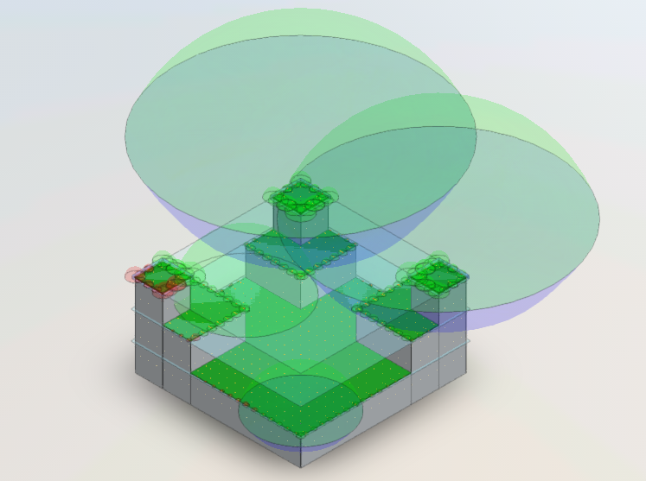

#### Completion Chart:

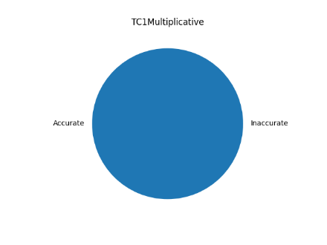

#### Multiplicative Inaccuracies

All of the POIs for Test case 1 were validated either against the VSCode script or the excel calculations. There are no non-compliant POIs to evaluate in this section.

#### Test Case 1 Sign-off

|  |  |
| --- | --- |
| By their representative's signatures below, the Client and Applied Software agree the scope of work has been completed. | |
| **nVent Erico** | **Applied Software Technology, Inc.** |
| Greg Martinjak |  |
| Name | Name |
| Sr. Development Engineer |  |
| Title | Title |
|  |  |
| Signature | Signature |
| 2022.11.10 |  |
| Date | Date |

### CVM TEST CASE 2 – V50

#### Cylindrical Cake Description:

Similar to the “Rectangular Castle”, the “Cylindrical Cake” will test the multiplicative and reductive abilities of the Ki engine, but now with recognizing when features are “cylindrical” and thus choosing the correct equations for these cases. This will feature multiple levels on a “cylindrical” base to test several criteria.

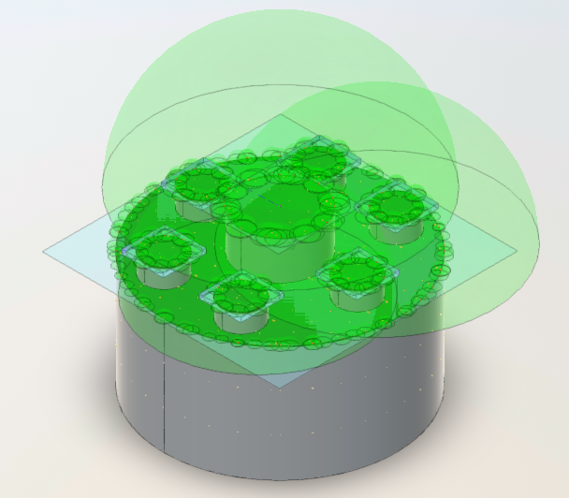

Completion Chart:

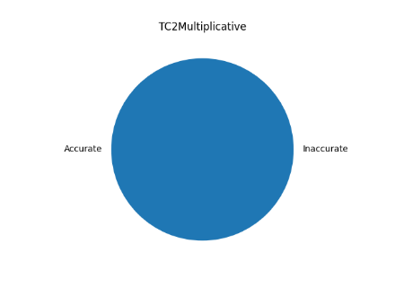

#### Multiplicative Inaccuracies

All of the POIs for Test case 2 were validated either against the VSCode script or the excel calculations. There are no non-compliant POIs to evaluate in this section.

#### Test Case 2 Sign-off

|  |  |
| --- | --- |
| By their representative's signatures below, the Client and Applied Software agree the scope of work has been completed. | |
| **nVent Erico** | **Applied Software Technology, Inc.** |
| Greg Martinjak |  |
| Name | Name |
| Sr. Development Engineer |  |
| Title | Title |
|  |  |
| Signature | Signature |
| 2022.11.10 |  |
| Date | Date |

### CVM TEST CASE 3 REV B – V26

#### Tall Apartments Description:

The “Tall Apartments” example is meant to look like a more refined model of a realistic building. With different parts of the building at different elevations, this model will give us an idea of how these kinds of multi-featured buildings will look to the Ki engine. Because the “main” roof is the highest and features some short roof equipment, we can use this data set to see how changing L0 can affect the overall Ki.

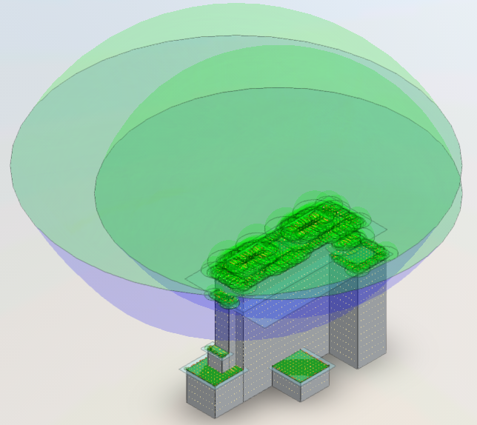

#### Completion Chart:

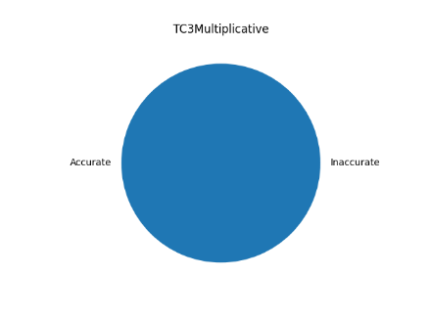

#### Multiplicative Inaccuracies

All of the POIs for Test case 3 were validated either against the VSCode script or the excel calculations. There are no non-compliant POIs to evaluate in this section.

#### Test Case 3 Sign-off

|  |  |
| --- | --- |
| By their representative's signatures below, the Client and Applied Software agree the scope of work has been completed. | |
| **nVent Erico** | **Applied Software Technology, Inc.** |
| Greg Martinjak |  |
| Name | Name |
| Sr. Development Engineer |  |
| Title | Title |
|  |  |
| Signature | Signature |
| 2022.11.10 |  |
| Date | Date |

### CVM TEST CASE 4 – V41

#### J-School Description:

The “J-School” case is one of the pre-made models for Revit testing. This model has been used for other systems with LPSD 4.0 and is a suitable example for single layer buildings with some equipment. The unique thing about this model is that the skylights are in a Gable roof pattern, that can be recognized by the Ki engine. This gives us a simple, yet very realistic example to model.

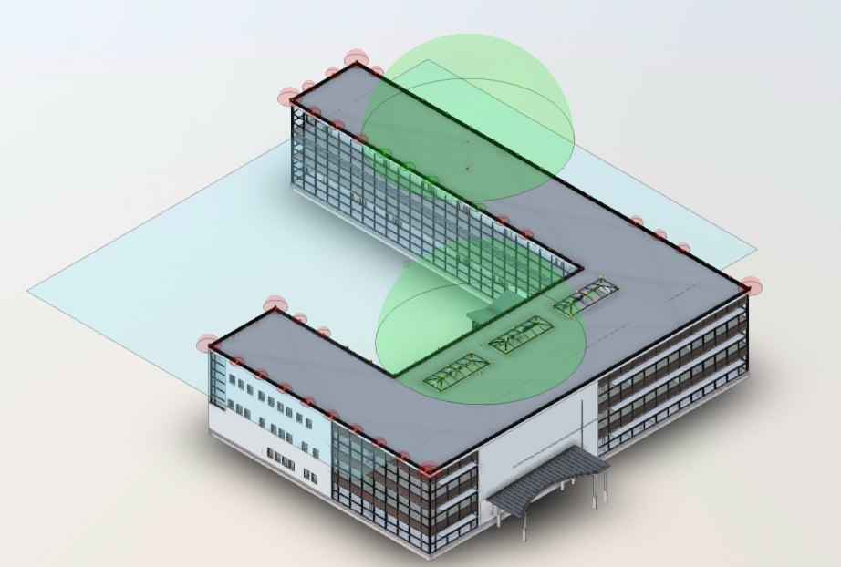

#### Completion Chart:

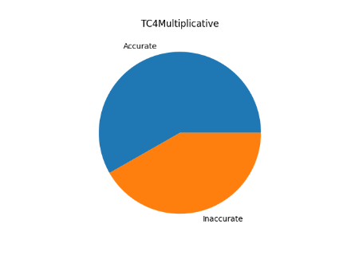

#### Multiplicative Inaccuracies

Many POIs were misplaced, not placed, or labeled incorrectly. The following POIs were marked as inaccurate:

|  |  |  |
| --- | --- | --- |
| 19 | 74-85 | 93 |

##### POI 19

POI 19 did not pull extended because feature was placed below point.



##### POI 74-85

These POIs were placed as surface horizontal which is not calculated:

##### POI 93

POI 93 was not placed on the model and the incorrect POI was pulled and compared.



#### Test Case 4 Sign-off

|  |  |
| --- | --- |
| By their representative's signatures below, the Client and Applied Software agree the scope of work has been completed. | |
| **nVent Erico** | **Applied Software Technology, Inc.** |
| Greg Martinjak |  |
| Name | Name |
| Sr. Development Engineer |  |
| Title | Title |
|  |  |
| Signature | Signature |
| 2022.11.10 |  |
| Date | Date |

### CVM TEST CASE 5 – V53

#### The Last Resort Description

It is commonly known that lightning will tend to attach to the taller features in the area. This makes urban environments and other tall buildings of particular interest, especially when used with CVM. The “Last Resort” is a fictional tall hotel with many floors with differently shaped layouts. This will provided us a tall building model example to use one its own, or with other smaller structures to test out more extreme examples of the reductive factor and de-rating angle.

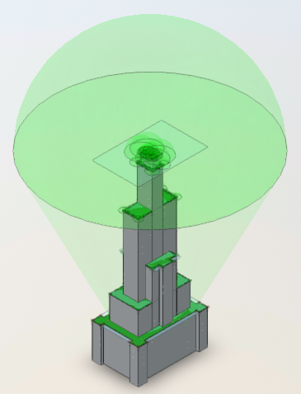

#### Completion Chart

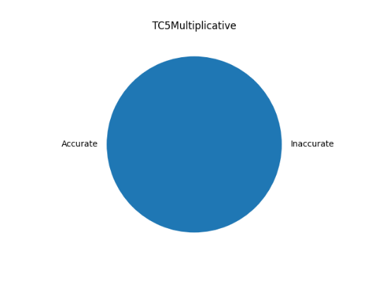

#### Multiplicative Inaccuracies

All of the POIs for Test case 5 were validated either against the VSCode script or the excel calculations. There are no non-compliant POIs to evaluate in this section.

#### Test Case 5 Sign-off

|  |  |
| --- | --- |
| By their representative's signatures below, the Client and Applied Software agree the scope of work has been completed. | |
| **nVent Erico** | **Applied Software Technology, Inc.** |
| Greg Martinjak |  |
| Name | Name |
| Sr. Development Engineer |  |
| Title | Title |
|  |  |
| Signature | Signature |
| 2022.11.10 |  |
| Date | Date |

### CVM TEST CASE 6F – V33

#### Substation Description

One of the most critical applications of CVM is within substations. CVM is best documented within the IEEE 998 standard which covers direct stroke lightning protection for substations. Also, since the largest market opportunity in North America for CVM and the nVent ERICO System 3000 is in this application, we should have a model that closely represents a typical installation and notes how LPSD 4.0 should be used here. This provides not only strategic value for our internal design process, but may also act as a good marketing and sales tool to approach early adopters of the new software for substation applications.

Revision F is specific to loading a single model consisting of all buildings in the Substation.

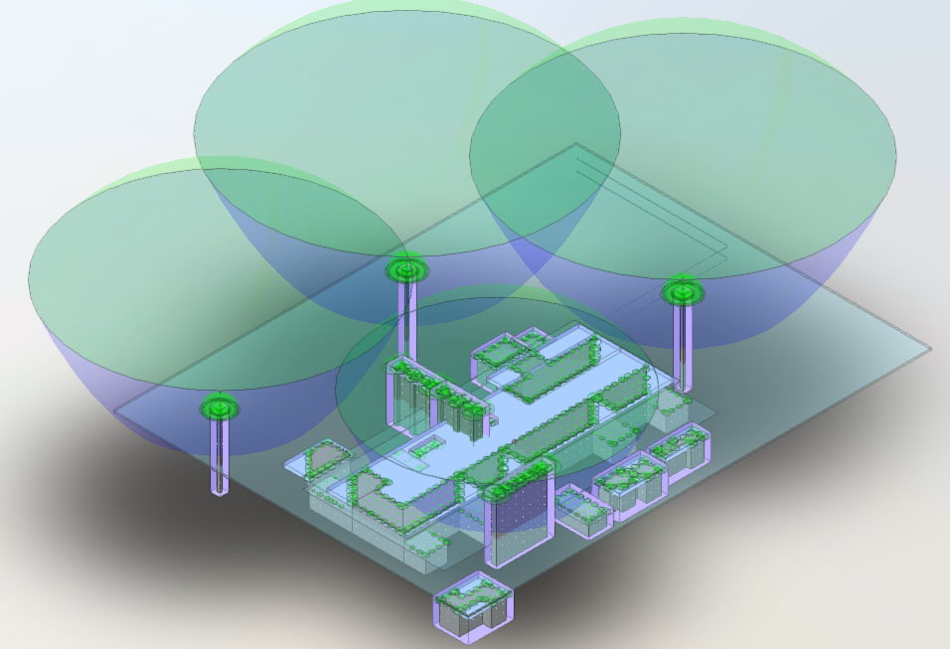

#### Completion Cart

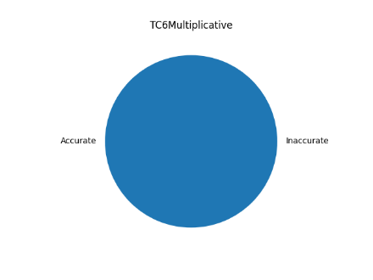

#### Multiplicative Inaccuracies

Only a single point was found to be non-compliant with the results and is documented below.

##### POI 34

POI 34 was calculated slightly differently than expected where the point is not extended and has a slightly lower Ki than expected. This may be due to some specific changes to equation B or equation L made during test case 7 investigations.



#### Test Case 6F Sign-off

|  |  |
| --- | --- |
| By their representative's signatures below, the Client and Applied Software agree the scope of work has been completed. | |
| **nVent Erico** | **Applied Software Technology, Inc.** |
| Greg Martinjak |  |
| Name | Name |
| Sr. Development Engineer |  |
| Title | Title |
|  |  |
| Signature | Signature |
| 2022.11.10 |  |
| Date | Date |

### CVM TEST CASE 7 – V55

#### Gable Roof Catchy Name Description

Gable roofs represent a common roof feature that we want to capture with the Ki engine. Sloped roofs are useful in buildings as they direct water and snow run-off towards common points to prevent leaking and loading the roof too much. This example will show multiple different styles of how gable roof features could be used and will check for the software’s accuracy.

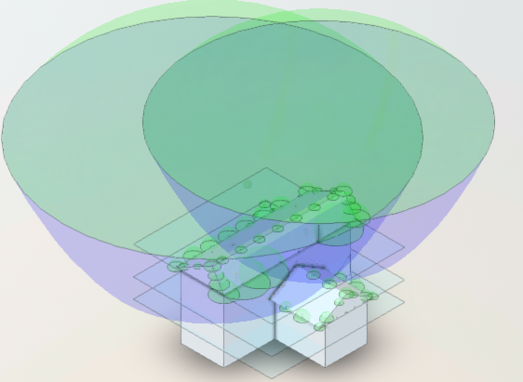

#### Completion Chart

[Not updated]

#### Multiplicative Inaccuracies

##### POI 11-12

POIs 11 and 12 came in higher than expected and given the timeline of the project were excluded from the requirements to pass test case 7 as they are conservatively high.



##### POI 52



#### Test Case 7 Sign-off

|  |  |
| --- | --- |
| By their representative's signatures below, the Client and Applied Software agree the scope of work has been completed. | |
| **nVent Erico** | **Applied Software Technology, Inc.** |
| Greg Martinjak |  |
| Name | Name |
| Sr. Development Engineer |  |
| Title | Title |
|  |  |
| Signature | Signature |
| 2022.11.10 |  |
| Date | Date |